SIMATS ENGINEERING
ASSESSMENT TOOL 1
COURSE NAME: COMPUTER ARCHITECTURE COURSE CODE: CSA12
COURSE OUTCOME COVERED
CO1: Analyze the functional units of a computer system including CPU, memory, bus structures, and I/O components by examining instruction execution cycles, addressing modes, and performance metrics such as CPI, clock cycles, and benchmarking (BL4) Assessment Tool Weightage: 40%
QUESTIONS:5 Total Marks:25
ANNEXURE A
APPLICATION BASED QUESTIONS
Code of Conduct:
I Shailaja S (192511026) certify that this submission is my original work and that I have adhered to the guidelines specified for this assessment. I understand that any violation of academic integrity rules will result in disciplinary action.

Signature of the student:
ANNEXURE A
- A smart city surveillance system processes continuous video feeds from multiple cameras, where large volumes of data are transferred between I/O devices, memory, and CPU. During peak hours, the system experiences lag and delayed response in threat detection. Analyze how the interaction between CPU, memory, and I/O contributes to this issue, and explain how different bus structures (single-bus vs multi-bus) and improvements in instruction execution cycle can enhance system performance.

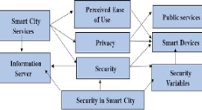
The lag in the smart city surveillance system occurs due to inefficient interaction between CPU, memory, and I/O devices. Large volumes of video data continuously flow from cameras (I/O) to memory and then to the CPU for processing. During peak hours, the system faces a bottleneck because all components compete for the same communication pathway.

In a single-bus architecture, only one data transfer can occur at a time, causing delays when multiple devices request access simultaneously. This leads to increased waiting time and reduced system throughput. In contrast, a multi-bus architecture separates memory, I/O, and CPU communication paths, allowing parallel data transfers and reducing congestion.
Thus, upgrading to a multi-bus system and optimizing instruction execution significantly enhances system performance and reduces lag.

- A real-time stock trading application running on a processor executes millions of instructions per second, but users report delays in transaction processing during high load. The system has a high CPI due to frequent memory access and branch instructions. Examine how the fetch–decode– execute cycle impacts execution time in this scenario, and propose methods to reduce CPI and improve overall CPU performance using suitable architectural enhancements.

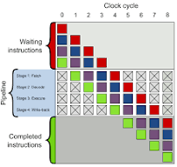

In the stock trading system, delays are caused by a high Cycles Per Instruction (CPI) due to frequent memory access and branch instructions. The fetch–decode–execute cycle is affected because the CPU must wait longer during instruction fetch (memory access) and execution (branch decisions).

IC =1000000
CPI=2.5
Clock=2e9

Time=(IC*CPI)/Clock
Print (“Execution Time =”, time, “seconds”)

- An embedded system based on an 8085 microprocessor is used in an industrial temperature control unit, where sensors provide input and actuators respond accordingly. However, incorrect temperature readings are occasionally processed due to improper use of addressing modes in the program. Discuss how different addressing modes influence data access, identify possible causes of such errors, and suggest how the instruction set of 8085 can be effectively used to ensure accurate and reliable operation.

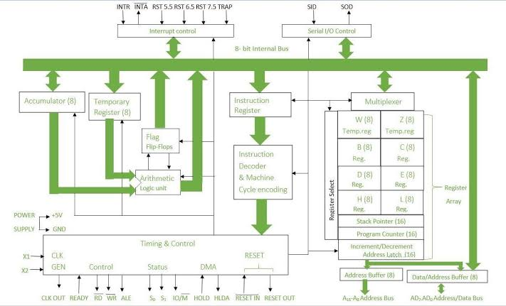

In the temperature control system, incorrect readings occur due to improper use of addressing modes, which determine how data is accessed.

The 8085 supports several addressing modes:
- Immediate addressing – data is directly given
- Direct addressing – memory address is specified
- Register addressing – data is in registers
- Indirect addressing – register holds memory address

To ensure accuracy:
- Use correct addressing mode based on application
- Validate memory locations before access
- Use proper instructions like MOV, LDA, STA, LXI
- Maintain proper register management

- A computing system uses an 8086 microprocessor with segmented memory for executing multiple programs simultaneously, but it encounters issues like incorrect data access and stack overflow errors. Evaluate how segmentation (code, data, and stack segments) works in 8086, analyze how improper segment handling can lead to such problems, and explain how instruction execution and addressing modes must be managed to ensure correct program execution.

The 8086 microprocessor uses segmented memory to manage programs efficiently. Memory is divided into:

- Code Segment (CS) – stores instructions
- Data Segment (DS) – stores data
- Stack Segment (SS) – handles stack operations
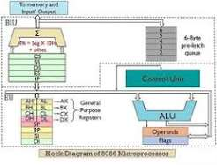

Physical address = segment *10H+offset
CS=2000H
IP=1500H
Physical address=21500H

Errors occur due to improper segment handling:
- Incorrect segment register values lead to wrong memory access
- Stack overflow occurs if stack is not properly managed
- Mixing data and code segments causes unpredictable behavior

- A data communication system represents packet information in hexadecimal format for ease of debugging and transmission, but a software engineer mistakenly interprets values, leading to incorrect data processing. Analyze the importance of number system conversions between hexadecimal and binary in such systems, explain how errors in conversion can affect instruction execution, and discuss how efficient CPU design and benchmarking can help detect and minimize such issues in real-time systems.

In data communication systems, hexadecimal representation is used for readability, while the CPU operates in binary. Incorrect conversion between these systems leads to wrong data interpretation and execution errors.

Hexadecimal simplifies large binary values (1 hex digit = 4 binary bits). If conversion is incorrect:

- Instructions may be misinterpreted
- Data values may become invalid
- System output becomes incorrect

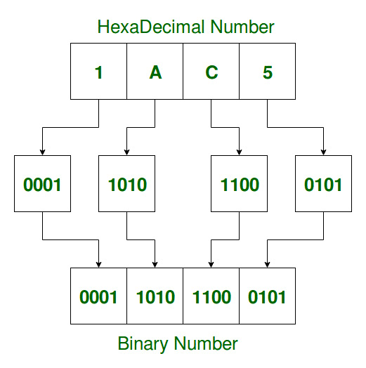

For example, wrong conversion of a hex value can change the opcode, leading to incorrect instruction execution.
To minimize errors:

- Use accurate conversion methods (grouping binary into 4 bits)
- Implement validation checks in software
- Use debugging tools to verify values



